**A**

**Mini Project Report**

**on**

# EVENT HORIZON

Submitted in partial fulfillment of the requirements for the

degree

**Second Year Engineering – Computer Science Engineering (Data Science)**

by

**Mr.Subodh Wani 23107070**

**Mr.Aditya Vishe 23107061**

**Mr.Rohit Yadav 23107053**

**Under the guidance of**

**Ms. Ashwini Rahude**

**DEPARTMENT OF COMPUTER SCIENCE ENGINEERING (DATA SCIENCE)**

## A.P. SHAH INSTITUTE OF TECHNOLOGY G.B. Road, Kasarvadavali, Thane (W)-400615 UNIVERSITY OF MUMBAI

**Academic year: 2024-25**

# CERTIFICATE

This to certify that the Mini Project report on EVENT HORIZON project has been submitted by Mr.Subodh Wani (23107070), Mr.Aditya Vishe(23107061)**,** Mr.Rohit Yadav (23107061)who are bonafide students of A. P. Shah Institute of Technology, Thane as a partial fulfillment of the requirement for the degree in **Computer Science Engineering(Data Science)**, during the academic year **2024-2025** in the satisfactory manner as per the curriculum laid down by University of Mumbai.

**Ms. Ashwini Rahude**

**Guide**

**Ms. Anagha Aher Dr. Uttam D. Kolekar**

**HOD, CSE(Data Science) Principal**

**External Examiner: Internal Examiner:**

**1. 1.**

**Place:** A. P. Shah Institute of Technology, Thane

**Date:**

# ACKNOWLEDGEMENT

This project would not have come to fruition without the invaluable help of our guide **Ms. Ashwini**

**Rahude** Expressing gratitude towards our HoD, **Ms. Anagha Aher**, and the Department of Computer Science Engineering (Data Science) for providing us with the opportunity as well as the support required to pursue this project. We would also like to thank our project coordinator **Ms. Aavani Nair and Ms. Richa Singh** who gave us her valuable suggestions and ideas when we were in need of them.

We would also like to thank our peers for their helpful suggestions.

|  |
| --- |
| **TABLE OF CONTENTS**   1. Introduction ................................................................................................................. 1    1. Purpose ............................................................................................................... 1    2. Problem Statement ............................................................................................... 2    3. Objectives ............................................................................................................ 3    4. Scope ................................................................................................................... 3 2. Proposed System……………………………………………………………………...4    1. Features and Functionality .................................................................................. 6 3. Project Outcomes ......................................................................................................... 7 4. Software Requirements ................................................................................................ 8 5. Project Design ............................................................................................................. .9 6. Project Scheduling ....................................................................................................... 10 7. Results………………………………………………………………………………...11 8. Conclusion ................................................................................................................... 13 9. References……………………………………………………………………………14 |

# Chapter 1

## Introduction

Event management is a fascinating field that involves planning, organizing, and executing various types of events, ranging from corporate conferences and trade shows to weddings and music festivals. It requires a blend of creativity, attention to detail, and superb organizational skills.

Event managers are responsible for overseeing all aspects of an event, including budgeting, scheduling, venue selection, logistics, and coordinating with vendors and participants.Their goal is to ensure that everything runs smoothly and meets the expectations of stakeholders.

**1.1 Purpose:**

The purpose of **event management** is to plan, organize, and execute events in a structured and efficient way to ensure their success. Whether it's a small gathering, a corporate meeting, a cultural festival, or a large-scale conference, event management involves a wide range of activities designed to create a seamless and engaging experience for participants, hosts, and stakeholders. Here are the key purposes of event management:

* **Planning and Organization:**

To plan every detail of the event, such as the location, schedule, and activities, to make sure everything runs smoothly.

* **Creating Enjoyable Experiences:**

To provide a fun, memorable, or valuable experience for everyone attending, whether it's a party, a conference, or a community event.

* **Meeting Goals:**

To achieve specific goals, like promoting a brand, raising money for a cause, or celebrating a special occasion.

**1.2. Problem statement:**

Event management is a complex and multifaceted discipline that involves meticulous planning and coordination. One of the primary challenges is managing multiple tasks, timelines, and stakeholders simultaneously. This requires a detailed plan that outlines every aspect of the event, from the initial concept to the final execution.

Budget constraints further complicate the process, as event managers must balance high quality experiences with financial limitations. This involves negotiating with vendors, sourcing cost effective solutions, and ensuring every expense contributes to the overall success of the event.

Another significant challenge in event management is ensuring attendee engagement and satisfaction. Creating a memorable and engaging experience that meets or exceeds attendee expectations requires innovative thinking and a deep understanding of the target audience. This includes everything from the event's theme and activities to the logistics of seating, food, and entertainment. Additionally, managing logistical elements such as venue setup, transportation, and accommodation can be daunting. Each of these components must be seamlessly integrated to create a cohesive and enjoyable experience for all participants.

Another significant challenge in event management is ensuring attendee engagement and satisfaction. Creating a memorable and engaging experience that meets or exceeds attendee expectations requires innovative thinking and a deep understanding of the target audience. This includes everything from the event's theme and activities to the logistics of seating, food, and entertainment. Additionally, managing logistical elements such as venue setup transportation, and accommodation can be daunting. Each of these components must be seamlessly integrated to create a cohesive and enjoyable experience for all participants.

11.3

**1.3. Objectives:**

* **Create a Great Experience**: Reduce long queues: Eligible voters can avoid long queues at polling places by enabling remote voting, which significantly assists individuals by saving time and decreasing the potential for vote manipulation.
* **Meet Event Goals:** Depending on the type of event, the goals can vary widely. For a business conference, it might be about networking and knowledge sharing. For a charity event, raising funds and awareness could be the focus.Every element of the event should be aligned with achieving these specific objectives.
* **Use Resources Wisely:** Efficient management of resources includes sticking to a budget, negotiating effectively with vendors, and making smart decisions about where to allocate funds.

**1.4. Scope:**

The scope of event management is vast and crosses multiple industries, each requiring specific skills and approaches. In the corporate sector, event managers are crucial for organizing conferences, seminars, product launches, and team-building activities, with a focus on networking, knowledge sharing, and brand promotion.

Social events, such as weddings, birthdays, and anniversaries, also heavily rely on the expertise of event managers to ensure these special occasions are memorable and run smoothly. Entertainment events, including concerts, music festivals, theater productions, and sports events, require meticulous planning to handle large crowds and deliver outstanding experiences. Additionally, non-profit organizations depend on event managers to organize fundraising events, charity galas, and awareness campaigns, maximizing impact and engagement. Exhibitions and trade shows further highlight the importance of event management, providing a platform for businesses to showcase their products and engage with potential clients.

The user interface will be designed to be intuitive and user-friendly for both voters and administrators, with accessibility features included to accommodate users with disabilities. The target audience includes voters wishing to participate in elections and administrators overseeing the electoral process.

# Chapter 2

## Proposed System

The proposed Event Management System aims to provide a comprehensive platform for organizing, booking, and managing events seamlessly. The system will allow users to browse available venues, book events, manage bookings, and track their status in real-time. For administrators, the system offers tools to approve or reject bookings, manage venues, and oversee event logistics. Integrated payment options will streamline the payment process, while user profiles and booking histories enhance personalization. The system will improve the efficiency of event planning and execution by automating key tasks, ensuring better coordination between users, event organizers, and vendors.

System Architecture:

* Frontend: Developed using Java with a user-friendly interface that allows user and administrators to interact seamlessly with the system.
* Backend: Implemented in Java, managing user authentication, processes, and database interactions.

Key Pages and Functionality:

* Login Page: Allows users (user and administrators) to securely log into the system. Features include username/password authentication and options for password recovery.
* Registration Page: Enables new users to create accounts by providing necessary personal information and verifying their identity. Ensures user data is securely stored in the database.
* User Page: Provides user with a list of events. Features an intuitive interface for users to cast their event easily and securely.

View Results Page:

* Displays real-time results of the event, including total events and their details.

* Ensures transparency in the event booking process by providing users with up-to-date information.

* Admin Manage Page: Allows administrators to create, manage, and schedule events.

User Interface Design:

* Simple and Intuitive Layout: The UI is designed for easy navigation, featuring clear buttons and forms that guide users for booking events.
* Accessibility: Ensures that all users, including those with disabilities, can easily interact with the system

**2.1 Features and Functionality**

The Event Management System will feature key functionalities to simplify event planning and enhance user interaction. Users can register, log in, browse available venues, and make bookings with real-time status updates. Integrated payment options streamline the booking process, and users can track their booking history. Admins have access to a dashboard where they can manage bookings, approve or reject requests, and generate reports for event analysis. Automated email notifications keep both users and admins informed, ensuring smooth communication and efficient event management.

User Registration and Authentication:

* User can easily register online, providing necessary details to create a secure account.

Remote Event book:

* User can book their event from any location with internet access, eliminating the need for physical polling places and significantly reducing wait times.
* A user-friendly interface guides user through the event booking, ensuring clarity and ease of use.

Automated Event Counting:

* The system automates the event counting process, reducing the likelihood of human error and ensuring accuracy.
* Events and their details are tabulated in real-time, providing immediate updates on election results.

Real-Time Results Display:

* A user can easily book an event and admin can easily approve status and give the quotation.

# Chapter 3

## Project Outcomes

The outcome of executed event management project is multifaceted and significant. Firstly,it ensures that all the event goals are met, whether it's achieving a high attendance rate, fostering meaningful connections, raising funds, or successfully launching a product.

These tangible results demonstrate the effectiveness and impact of the event.

* Enhanced Reputation and Brand Image: Attendees leave with a positive impression, increasing loyalty, word-of-mouth promotion, and future participation, while establishing the event's quality and professionalism.

* Real-Time Event Status Tracking: Users can view the status of their event bookings (approved, pending, or rejected) in real-time. Admins can update the status easily, and users will get immediate updates.

* Booking History Management: Users can access their past bookings, including details like event date, venue, number of attendees, and payment status, ensuring transparency and record-keeping.

* Admin Control and Approval System: A streamlined system where admins can review, approve, or reject event bookings. This ensures that event management teams can maintain oversight and control over venue availability and event scheduling.

# Chapter 4

## Software Requirements

The Event Management System will be developed using Java, with NetBeans or Eclipse as the IDE and requires JDK 8 or above. MySQL will be used for managing event data and bookings, while Apache Tomcat will host the application. The system will utilize Java Swing for the desktop interface and JDBC for database connectivity. Optional integrations like PayPal for payments and JavaMail for email notifications may also be included.

**Operating System**:

* Windows 10 or later

* Linux (Ubuntu 20.04 or later)

**Java Environment**:

* Java Development Kit (JDK) 11 or later

* Java Runtime Environment (JRE) 11 or later

**Development Environment**:

* NetBeans IDE

**Database Management System**:

* MySQL 5.7 or later

# Chapter 5

## Project Design

The Event Management System is designed to streamline event planning, booking, and management processes. It features a user-friendly interface for browsing and booking events, while admins can manage events and approvals through a dedicated dashboard. The system uses MySQL for database management.

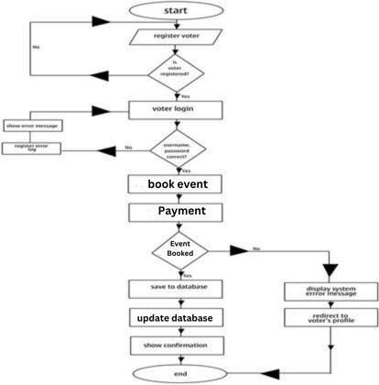

### Fig 5.1 Project design

This Flowchart represents the purpose structure of a online voting system. It starts with the Register voter, which serves as the entry point for voters. From the Registered voters can either sign up for a new account or access various services.

* Registration: New user register
* Login: Registered user log in with their credentials.
* Booking: User can book an event.

# Chapter 6

## Project Scheduling

The Project Scheduling outlines key tasks like design, development, and testing, each with specific timelines. A Gantt Chart visually maps out these tasks, showing their duration and dependencies. This helps track progress and ensures the project stays on schedule for timely completion.

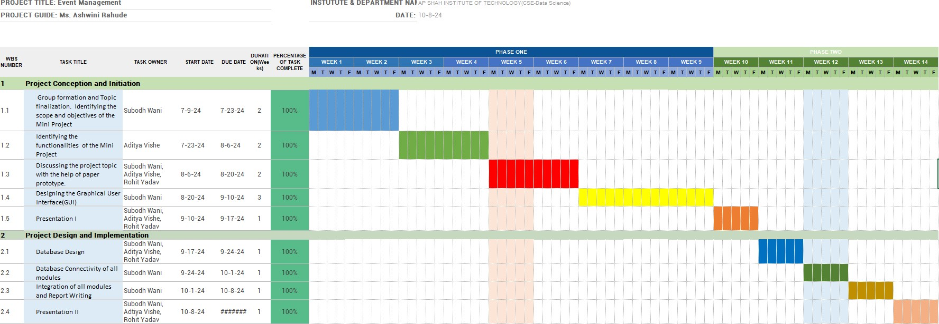

### Fig 6.1 Gantt chart

In Phase 1: Project Conception and Initiation, the team successfully formed groups and initiated the project within the first week. Subodh and Aditya identified the project scope and objectives, while Rohit finalized the project title by the end of Week 2. The UI/UX design work is currently ongoing. In Phase 2: Project Design and Implementation, Subodh and Aditya completed the database design, followed by Subodh and Rohit establishing database connectivity. Subodh is now focusing on the integration of modules, ensuring a cohesive system for the Event Management application.

**Chapter 7**

# Result

The Event Management System project achieved its objectives by defining the scope, designing the user interface, and using SQL as the database. The integration of modules created a cohesive system that streamlines event planning and management. Incorporating user feedback led to improved functionality, resulting in greater efficiency and user satisfaction, while establishing a solid foundation for future enhancements.

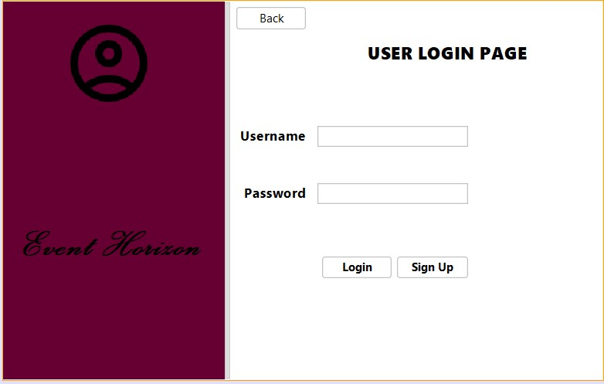

**Fig 7.1 Home page**

In Fig 7.1 Home page offers easy navigation options, allowing users to either sign up or register for a new account and access event management services

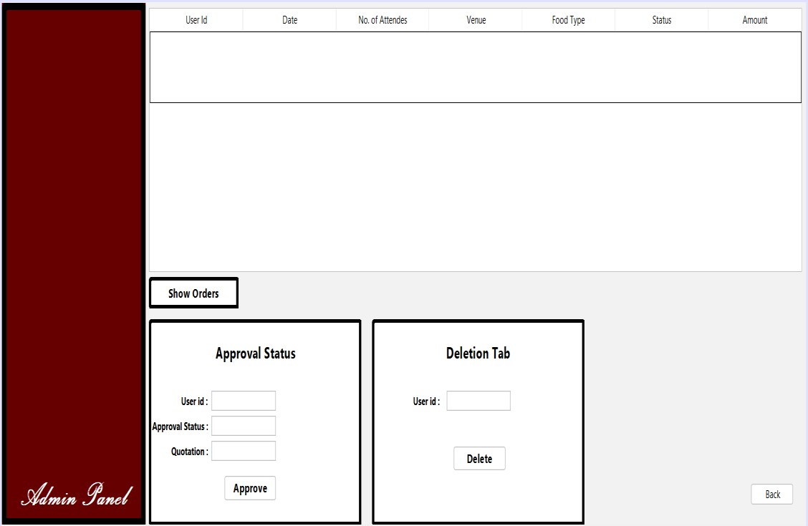

## Fig 7.2 Admin’s Page

In Fig 7.2 Admin’s page helps admin to access and manage events, and view results too.

Can see the user’s events and can delete it if want.



**Fig**

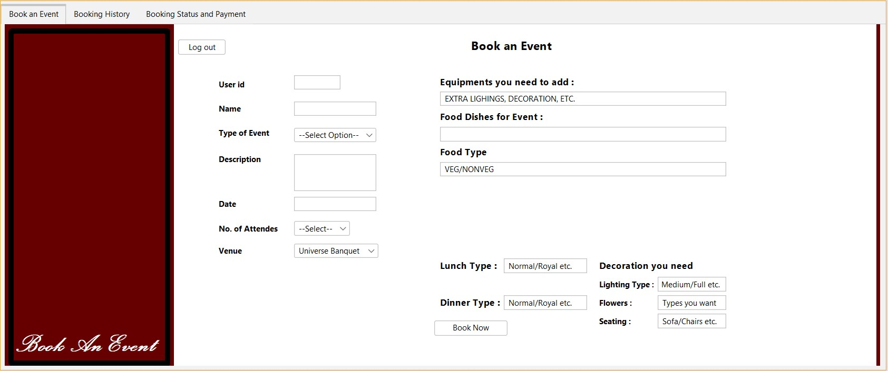

## Fig 7.3 User Page

In Fig7.3 User signup page where user can easily book and event and can easily manage the event.

# Chapter 8

## Conclusion

In conclusion, event management plays a crucial role in the successful planning and execution of various types of events, from small gatherings to large-scale conferences. It involves careful coordination, strategic planning, and attention to detail to ensure that every aspect of the event runs smoothly. An effective event management system enhances organization, improves user experiences, streamlines communication, and helps achieve event goals, such as brand promotion or community engagement. By integrating tools for booking, status tracking, payment management, and reporting, event management systems not only simplify the event planning process but also contribute to the overall success and satisfaction of all stakeholders involved.

Event management is more than just organizing an event; it is about creating an experience that resonates with attendees and achieves the goals of the organizers. With the right event management strategies in place, events can be planned with precision, ensuring all aspects, such as logistics, entertainment, catering, and venue management, are handled effectively. The use of event management systems allows for streamlined processes, reducing manual tasks and enabling event planners to focus on delivering high-quality experiences. This also enhances communication between users, vendors, and organizers, ensuring everyone is on the same page and potential risks or challenges are addressed proactively.

Moreover, in today’s digital age, an event management system provides essential tools for monitoring and analyzing key event metrics, such as attendance, user satisfaction, and financial outcomes. These insights enable continuous improvement for future events. From efficient booking systems to real-time updates and user feedback, technology has transformed the way events are managed. As a result, event management not only simplifies planning but also elevates the overall execution of events, leaving a lasting positive impression on both attendees and hosts.

# Chapter 9

**References:**

1. Lynn Van Der Wagen and Lauren White, "Event Management: For Tourism, Cultural, Business, and Sporting Events”, Vol. No. 11.

1. Bowdin, G., Allen, J., O'Toole, W., Harris, R., & McDonnell, I**.** (2011). Events Management (3rd ed.). Butterworth-Heinemann

1. Industry trends, event management best practices, and tips for organizing successful events. [https://www.eventbrite.com/blog,](https://www.eventbrite.com/blog).

1. Donald Getz, “Theory, Research, and Policy for Planned Events by Donald Getz”: A foundational academic text that explores event management theories, research methods, and policy considerations for planned event.